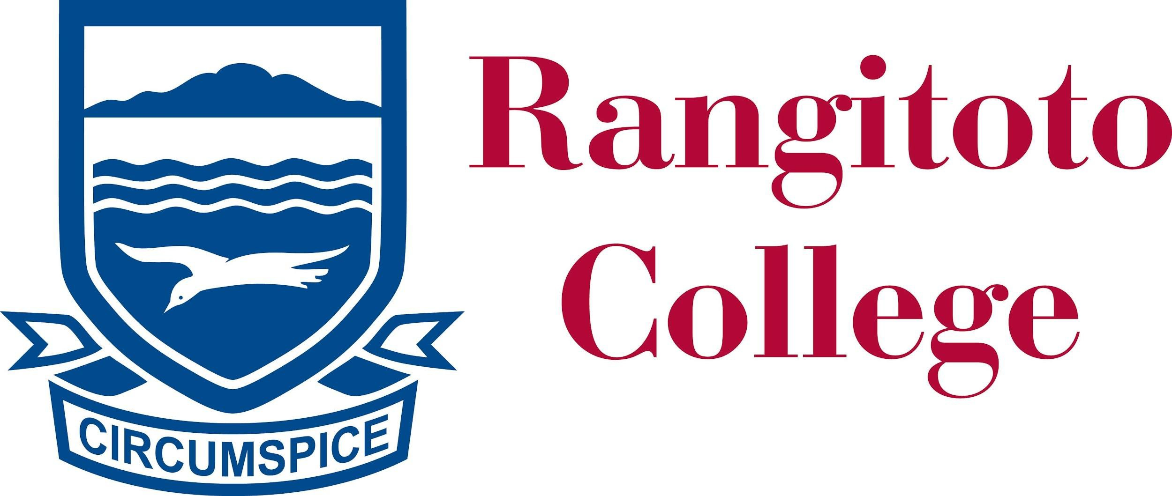

DIRECTOR OF HOCKEY- JOB DESCRIPTION
Purpose
The purpose of this role is to build an outstanding Hockey programme that creates a deﬁned pathway from participation through to performance that enables the sport to grow. The Director will oversee the delivery of Hockey in the college to ensure consistency, engagement and support for players and coaches across the pathway. The Director will embody the values of the college and be the face of Hockey for Rangitoto College in the community.
Reports to: The Director of Sport and the Principal.
Fee: $25,000
Hours and deliverables will vary by the school term and will be negotiated with the Director of Sport
An example of a what a possible schedule may look like:
 | Weeks | Hours/Week
Term 1 | 10 | 6
Term 2 | 10 | 20
Term 3 | 10 | 20
Term 4 | 9 | 6
An example of what a weekly 20 hour schedule may look like: 2 x Full Squad evening training sessions = 6 hours
1 x Evening Positional Speciﬁc Skills Session = 2 hours
2 x Morning/Lunch Skills Clinics = 4 hours Attendance at ﬁxtures = 4 hours
1 x Community Session = 2 hours Administration time = 2 hours

Deliverables
- Organisation

Create a development plan for all facets of the programme that incorporates the technical, tactical, physical, and mental aspects of the sport.
Collaborate with other various roles involved in the programme including the Teacher in Charge, Sports Coordinator, Sports Performance Academy Coach and Strength and Conditioning Coach to ensure the success of the programme. Evaluate and report on the programme as part of a review process.

- Talent Identiﬁcation
Lead the delivery and planning for recruitment and talent identiﬁcation and include a succession planning document to support this process
Assist with the selection of teams throughout the pathway.
- Coach Development

Work with coaches to design training sessions and resources that:
  - Provide a player centered approach
  - Create a consistent game model through the pathways
  - Promote player-led decision making

Create and promote an eﬀective and positive game day experience. Provide coach development sessions.
Begin to recruit and screen potential new coaches, creating a talent pipeline for the future.

Player Development

Provide an individual development plan and a mentor for identiﬁed players. Organise positional-speciﬁc sessions for players across the pathway.
Plan new initiatives and “have a go” opportunities to enhance student participation.

Effective management and planning around player recruitment and retention from year to year, consistent across all levels of Hockey.

Plan and deliver effective Sports Performance Academy sessions for Junior students within Hockey.

Community Engagement

Actively participate in communication and sharing of information with the community while maintaining strong relationships within and beyond Rangitoto College.
Work with local schools to identify and support talented athletes to promote a smooth transition into Rangitoto College.
Regular engagement with key stakeholders including local clubs and regional/national organisations

..................................................... ……………………………………......

Director of Hockey Date

..................................................... ……………………………………......

Director of Sport

Ryan Borthwick Date

